For Immediate Release
January 19th, 2012

DEFILER Announce North American Tour with WAYNE STATIC & POLKADOT CADAVER

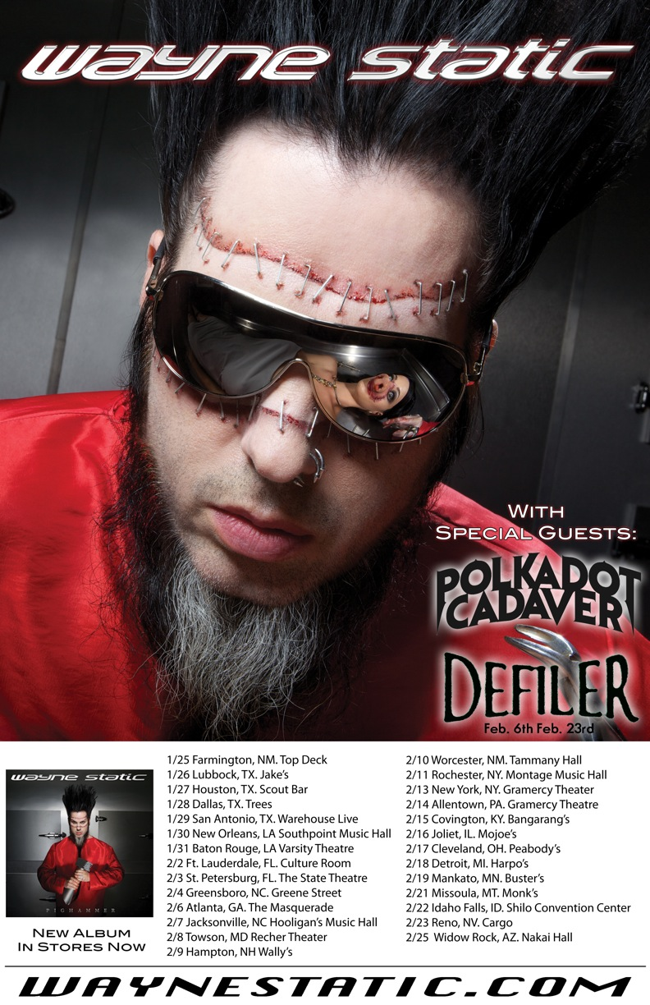

Castro Valley, CA's DEFILER, who recently re-issued their debut album, Pangaea, through Stillborn Records (click here to purchase), will be hitting the road this February in support of Wayne Static and Polkadot Cadaver, hitting a myriad of cities never before played by the band. DEFILER will join the tour on February 6th in Atlanta, GA and will be making their way up the East Coast and back towards home, finishing up in Reno, NV. The band will be performing a number of new songs while on the road.

DEFILER also recently inked a record deal with a new label home, more details to be announced soon.

DEFILER US Tour Dates with Wayne Static and Polkadot Cadaver:
Feb 6 Atlanta, GA @ Masquerade
Feb 7 Jacksonville, NC @ Hooligan's Music Hall
Feb 8 Towson, MD @ Recher Theater
Feb 9 Hampton, NH @ Wally's
Feb 10 Worcester, MA @ Tammany Hall
Feb 11 Rochester, NY @ Montage Music Hall
Feb 13 New York, NY @ Gramercy Theatre
Feb 14 Allentown, PA @ Crocodile Rock
Feb 15 Covington, KY @ Bangarang's
Feb 16 Joliet, IL @ Mojoe's
Feb 17 Cleveland, OH @ Peabody's
Feb 18 Detroit, MI @ Harpo's
Feb 19 Mankata, MN @ Buster's
Feb 21 Missoula, MT @ Monk's
Feb 22 Idaho Falls, ID @ Shiloh Convention Center
Feb 23 Reno, NV @ Cargo

DEFILER is:
Jake Pelzl (founding member and vocalist)
Ethan Lewis - (guitar)
Ian Poole - (Drums)

For more information on DEFILER, please visit these websites:

www.facebook.com/defilerband
www.twitter.com/defilerofficial
www.youtube.com/defilerband1

For press inquiries and additional information, please contact Adrenaline PR and Maria Ferrero at 732-462-4262 or maria@adrenalinepr.com.

--
To unsubscribe from Adrenaline PR press releases, please send an email to unsubscribe@adrenalinepr.com with your email address as the subject.

Adrenaline PR:
A boutique independent public relations firm notoriously credible for the successful promotion of artists, events, musicians, film, lifestyle, books, and talent. Adrenaline PR is known for their prowess in targeting niche demographics and securing national covers, major features, television appearances, regional press in daily papers, weeklies, monthlies as well as websites and beyond. Adrenaline PR’s strengths include tapping into entertainment, culture and lifestyle while crossing over into mainstream, and are trusted to deliver beyond what is expected. Adrenaline PR possesses three decades of experience launching careers and building scene giants such as 10 Years, 2010 American Idol winner Lee DeWyze, All That Remains, Anthrax, As I Lay Dying, Atreyu, Dethklok, Dimmu Borgir, Down, Every Time I Die, Ferret Music, Five Finger Death Punch, From Autumn to Ashes, Good Fight Entertainment, GWAR, Housecore Records, Killswitch Engage, KMFDM, Lamb of God, Live Nation concerts, Machine Head, Mudvayne, Norma Jean, Operatica, Peter Murphy, Sevendust, Shadows Fall, Superjoint Ritual, Testament, Unearth, and tribute albums for the Smashing Pumpkins, Black Flag, and many more. Adrenaline PR boasts an impressive touring roster history, promoting MTV2 Headbangers Ball Tours, REPO! The Genetic Opera Road Tour, Rockstar Energy Drink Mayhem Festival, Sounds of the Underground, The Cool Tour, Thrash and Burn Tour, along with industry events such as the Alternative Press Magazine 20th Anniversary (My Chemical Romance, The Used and Say Anything). Adrenaline PR’s expertise coupled with their connections and relationships continue to build the firm into other areas of the arts, film, soundtracks and books, including The Punisher (soundtrack), REPO! The Genetic Opera (film), The Armageddon Chord (horror fiction novel), Precious Metal (book), Derek Hess (art book & calendar), Jeremy Saffer (photography book) and Paul Booth - The King of Rock and Roll Tattoo.

For more information on Adrenaline PR and the roster, visit www.adrenalinepr.com, and follow us on Facebook and Twitter!

