For Immediate Release
May 14, 2013

Maldivian Heavy Metallers NOTHNEGAL: New Supernatural-Themed EP Hits Digital Retailers on July 9, 2013 via Season of Mist

Produced by Shamheed, Matt Hyde (Slipknot, Bullet for My Valentine, Machine Head), Paul Reeve (MUSE)

Touring this June in India with HACRIDE

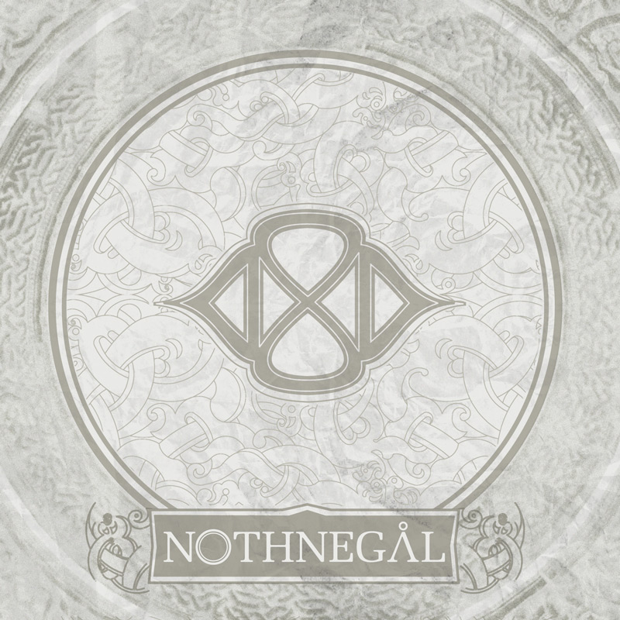

Maldivian melodic heavy metal band NOTHNEGAL will release their new self-titled EP on July 9, 2013 via Season of Mist. The EP was recorded at Vakaruge Studios in the Maldives with producer Shamheed, with additional production being handled by Matt Hyde (Slipknot, Bullet for My Valentine, As I Lay Dying) and Paul Reeve (MUSE). The NOTHNEGAL EP will consist of four tracks and will be released exclusively through digital retailers in North America and other parts of the world.

This is NOTHNEGAL’s first release with new vocalist Affan and new guitarist Chippe (Serenity Dies), who is currently filling in for longtime NOTHNEGAL guitarist Fufu. The band describes the EP’s sound as “very raw and organic with minimal electronic effects”. Elements such as the “boduberu” (log drums used in the Maldives) and other ambient sounds from the Maldivian environment were gathered for the new album.

Overall, the new music aims to explore the supernatural realm and people who have experienced paranormal encounters and/or have been possessed, offering a glimpse into these beings and false conspiracies. The EP shines a light on the folklore, beliefs and legends of the Maldivian islands and begs the listener to question their own spiritual state and vulnerability. The themes of the EP also include current social issues such as child abuse, corruption and family related problems.

Stay tuned for music set to be revealed soon.

NOTHNEGAL is touring this June in India with French progressive metallers HACRIDE. See below for the confirmed tour dates. Venues coming soon.

INDIA: Co-Headline tour with Hacride:
08 Jun 13 Hyderabad (IN) 10 Sports Bar
12 Jun 13 Mumbai (IN) United 1
14 Jun 13 Nasik (IN) TBA
15 Jun 13 Kolkata (IN) Nazrul Mancha
16 Jun 13 Delhi (IN) Blue Frog

NOTHNEGAL is:
Affan (Vocals)
Hamad (Bass)
Hilarl (Guitar)
Chippe (Guitar)
Marco Sneck (Keyboards)
Kevin Talley (Drums)

For more information on NOTHNEGAL, please visit these websites:
www.nothnegal.net
www.facebook.com/nothnegal ‎
www.twitter.com/Nothnegal ‎
www.myspace.com/nothnegal ‎
www.youtube.com/user/NothnegalOfficial

For press inquiries and additional information, please contact Adrenaline PR and Maria Ferrero at 732-462-4262 or maria@adrenalinepr.com.

--
To unsubscribe from Adrenaline PR press releases, please send an email to unsubscribe@adrenalinepr.com with your email address as the subject.

Adrenaline PR:
A boutique independent public relations firm notoriously credible for the successful promotion of artists, events, musicians, film, lifestyle, books, and talent. Adrenaline PR is known for their prowess in targeting niche demographics and securing national covers, major features, television appearances, regional press in daily papers, weeklies, monthlies as well as websites andbeyond. Adrenaline PR’s strengths include tapping into entertainment, culture and lifestyle while crossing over into mainstream, and are trusted to deliver beyond what is expected. Adrenaline PR possesses three decades of experience launching careers and building scene giants such as 10 Years, 2010 American Idol winner Lee DeWyze, All That Remains, Anthrax, As I Lay Dying, Atreyu, Brendon Small’s Galaktikon, Dethklok, Dimmu Borgir, Down, Every Time I Die, Ferret Music, Five Finger Death Punch, From Autumn to Ashes, Good Fight Entertainment, GWAR, Hank3, Housecore Records, John 5, Killswitch Engage, KMFDM, Lamb of God, Live Nation concerts, Machine Head, Mudvayne, Norma Jean, Operatica, Peter Murphy, Sevendust, Shadows Fall, Superjoint Ritual, Testament, Unearth, and tribute albums for the Smashing Pumpkins, Black Flag, and manymore. Adrenaline PR boasts an impressive touring roster history, promoting MTV2 Headbangers Ball Tours, REPO! The Genetic Opera Road Tour, Rockstar Energy Drink Mayhem Festival, Sounds of the Underground, TheCool Tour, Thrash and Burn Tour, along with industry events such as the Alternative Press Magazine 20th Anniversary (My Chemical Romance, The Used and Say Anything) and regional festivals such as Jackson, MI’s Rockapalooza. Adrenaline PR’s expertise coupled with their connections and relationships continue to build the firm into other areas of the arts, film, soundtracks and books, including Clutter Media Group, The Punisher (soundtrack), REPO! The Genetic Opera (film), The Armageddon Chord (horror fiction novel), PreciousMetal (book), Derek Hess (art book & calendar), Jeremy Saffer (photography book) and Paul Booth - The King of Rock and Roll Tattoo.

For more information on Adrenaline PR and the roster, visit www.adrenalinepr.com, and follow us on Facebook and Twitter!

