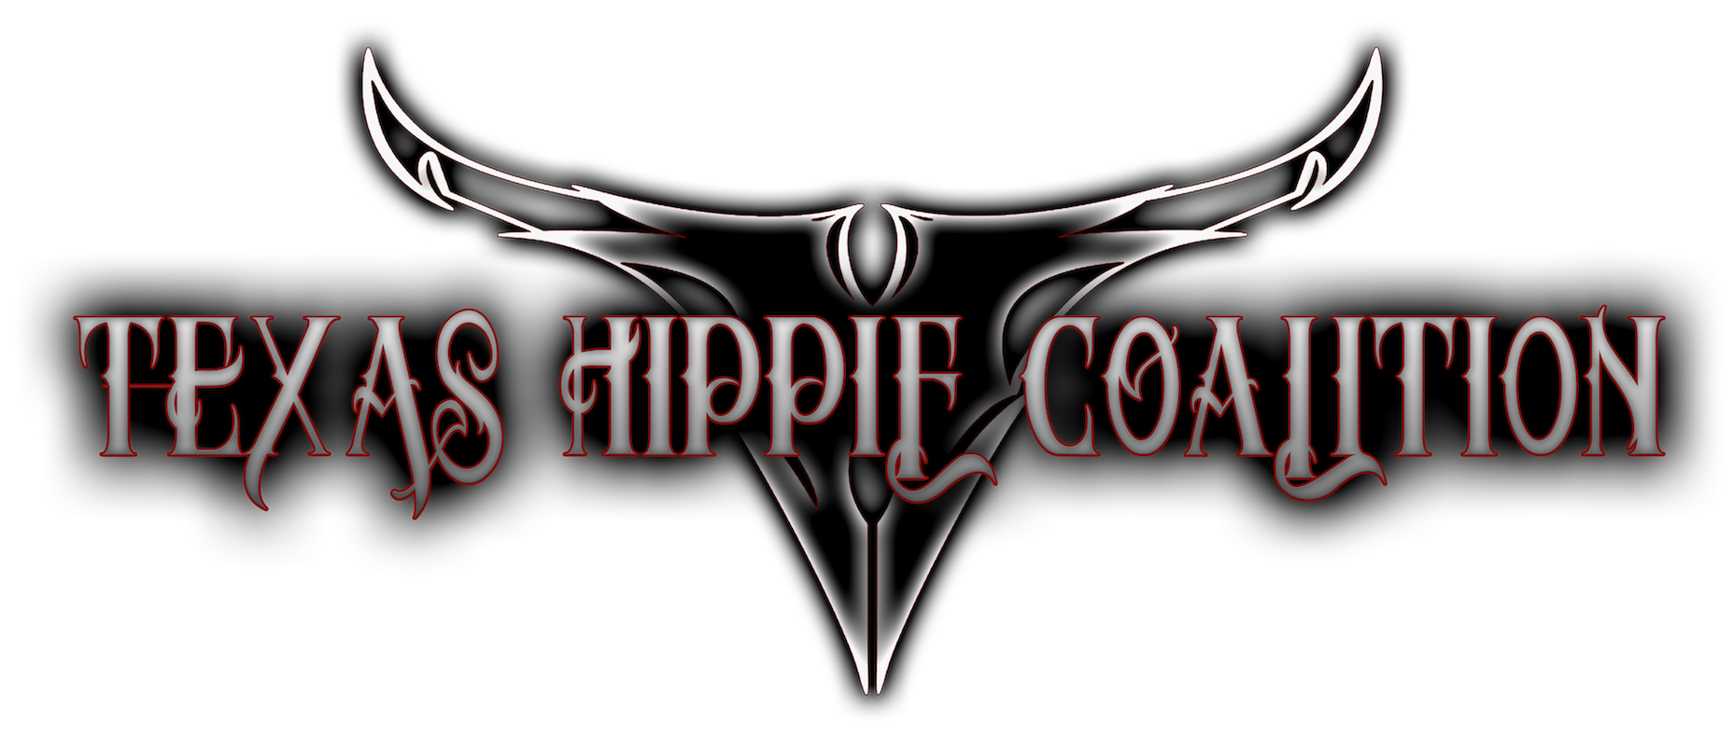

Rock ‘n’ roll is all about cutting loose. It’s about throwing back a few drinks, raising your hands, banging your head, and living out loud. Texas Hippie Coalition cook up the soundtrack to your “good time” with their fourth full-length album, *Ride On* [Carved Records]. Their countrified blues riffs simmer with metallic edge, while each chorus ignites a sing-a-long. The Texas quartet—Big Dad Ritch [vocals], John Exall [bass], Cord Pool [guitar], and Timmy Braun [drums]—have formally landed, and they brought the party with them, in more ways than one.

Nobody describes Texas Hippie Coalition better than Big Dad Ritch does. He grins, “It’s like Lynyrd Skynyrd and ZZ Top had a child, and Pantera ended up raising it. We’re Red Dirt Metal. That’s a flag we wave high. There wasn’t a line formed for us, so I created a line and jumped to the front of that bad boy. *Ride On* is the best example of what we do.”

In order to cut this big, bombastic, and ballsy ten-song collection, the boys retreated from their native Denison, TX to Nashville, TN. Hitting the iconic Sound Kitchen Studios, they teamed up with Grammy Award-winning producer Skidd Mills [Skillet, Saving Abel] for the first time. Cord had only entered the fold in 2013, but he immediately became an integral part of the writing and recording process.

“When we got to Nashville, Cord, Skidd, and I were writing two or three songs a day,” Big Dad Ritch goes on. “We wrote the whole album pretty fast. Skidd’s a great guy, and he’s very easy to work with. My brain fires like lightning. Once an idea hits my head, I’m off and running. Skidd kept up with us. It was one of the fastest albums I’ve ever put together.”

That urgency carries over to the album opener “El Diablo Rojo". The riff cocks like a shotgun before breaking into a devilishly catchy verse. Big Dad Ritch explains, "When we go down to El Paso, which we like to call 'Hell Paso', everybody calls me 'El Diablo Rojo'. It means 'Red Devil'. I always loved that, and I knew it needed to be on the album."

Then, there’s “Rock Ain’t Dead” which begins with a stadium-size stomp refuting Marilyn Manson’s old claim “Rock is Dead”. Big Dad Ritch hilariously contends, “We wanted to make sure people know the state of rock music is not nearly as bad as radio projects it to be. We needed to let y’all know rock ‘n’ roll ain’t dead. It’s just been in rehab. There’s no need to recover. Let’s all just stay strung out.”

Crashing between a chunky guitar wallop and big bass thud, "Fire In The Hole" immediately explodes on impact. “With this album, I wanted to make the world know that not only do we exist, but we’re here to take over,” declares the vocalist. “This is me warning you that we’re coming out you like an air raid. We’re here. We’re in your face. We’re going to bomb everybody with some THC. That’s the theme.”

Elsewhere on the record, Texas Hippie Coalition teamed up with longtime collaborator the iconic Bob Marlette [Pink Floyd, Rob Zombie] to co-write “Bottom of a Bottle”, “I Am The End”, “Ride On”, and “Go Pro”. The latter begins with a clean southern verse before breaking into a triumphant bruiser of a refrain. The singer adds, “It’s a big middle-finger-in-the-air song. It lets people know Texas Hippie Coalition isn’t going anywhere. You’ve got your champions, but you’re about to get one more—this band of outlaws.”

At the same time, Big Dad Ritch lyrically opens up on the pensive and powerful title track, which rounds out this roller coaster ride. Beginning with another guitar groundswell, it burns into one final message from the band. “My dad used to always say ‘Ride On’,” he continues. “It’s something special to me. I live by it. If the Lord gives me a bad road, I get on my bike and ride it out. No matter how bad it is, you can always ride on.”

Texas Hippie Coalition continue riding high after three critically acclaimed albums—*Pride of Texas* [2008], *Rollin* [2010], and *Peacemaker* [2012], which debuted in the Top 20 of *Billboard*’s Top Hard Rock Albums Chart. They’ve left crowds drunk, disorderly, and begging for more everywhere from *Rock on the Range* and *Rocklahoma* to the *Rockstar Energy Mayhem Festival*. Now, they’re coming for you.

“We’re about swigging the whisky, smoking the weed, and letting the women chase us,” Big Dad Ritch leaves off. “When I first started this band, I thought, ‘There’s an appetite for this sort of music. Once I got in front of people, I saw it wasn’t just an appetite. It was a hunger. The masses are starving to death for this kind of music. Who’s eating with me? I’m serving up some good old Texas Barbecue known as THC.”