**For Immediate Release**

**March 7, 2019**

**Psychedelic Metal Trio DRUIDS Explore the Afterlife with New Album, “Monument”, out April 19, 2019**

**Listen to New Track “The Whip” Now via** [**Metal Injection**](http://www.metalinjection.net/av/new-music/druids-bring-their-unique-brand-of-furious-sludge-on-new-song-the-whip)

**Pre-Order Now via** [**Bandcamp**](https://druidsiowa.bandcamp.com/album/monument) **| Vinyl Available via** [**The Company KC**](https://thecompanykc.bigcartel.com/)

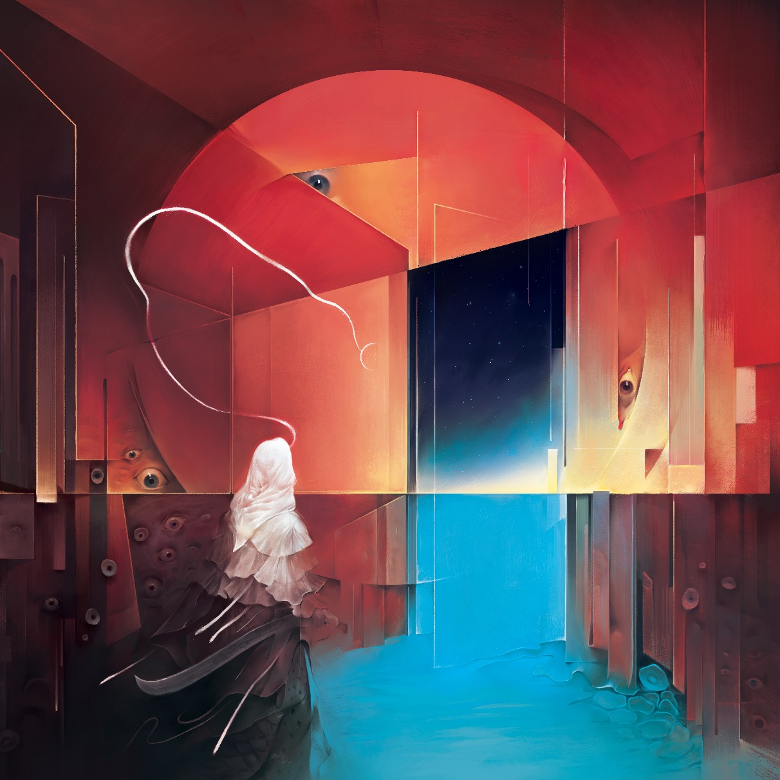

***Monument* Album Art by Mark Facey**

Des Moines, Iowa-based psychedelic/stoner metal trio **DRUIDS** have been making their rounds in the underground for the better part of a decade, but are poised to break out in 2019 with what will prove to be their most confident and explorative effort to date. The trio’s brand new five-track record, ***Monument***, is scheduled for release on April 19, 2019 via The Company KC and is available to pre-order beginning today via Bandcamp: <https://druidsiowa.bandcamp.com/album/monument>

Exclusive multi-colored vinyl is also available via The Company KC here: <https://thecompanykc.bigcartel.com/>

Today – aptly demonstrating their objective of creating music that is loud, crushing and beautiful while painting lush, vast soundscapes – **DRUIDS** are leading with a brand new track, “The Whip”. The unrelenting, blues-hybrid head-bobber offers a small glimpse of the heaviness of ***Monument*** without spoiling the album’s more mind-bending, experimental contributions.

Listen to “The Whip” now via **Metal Injection**: <http://www.metalinjection.net/av/new-music/druids-bring-their-unique-brand-of-furious-sludge-on-new-song-the-whip>

Though ***Monument*** is an absolute classic metal-inspired riffscapade on its surface, there’s much more lying beneath its sonic exterior. Amid the ebb and flow of atmosphere and groove-heavy passages, the album tells a story – inviting the listener on a journey through the afterlife. Each song on ***Monument*** depicts the experiences of mystical worlds that the story’s protagonist encounters after death, and ultimately grows from. Some lessons are beautiful, and some brutal. Although they have departed from their world, they are still learning and growing as a spirit.

Guitarist/vocalist Luke Rauch says, *“There are personal experiences in the lyrics, as even now, I feel the band and myself growing in the way the character does.”*

Bassist/vocalist Drew Rauch says about “The Whip”, *“This is one of the more high-energy songs on the album. We wrote it with the guitar being a driving force, and really wanted a bigger solo section in this particular song as well. Lyrically, “The Whip” takes us through more of a high-action part of the story, describing the harsh conditions of the desert world of the afterlife and the people that live within it. It’s a tough, strict life that they live.”*

***Monument* track listing:**

1) New Breath

2) Iron Healer

3) Mirrors of Trigon

4) The Whip

5) Shivast

***Monument*** was produced by Brandon Darner, engineered and mixed by Micah Natera, and mastered by Doug Van Sloan.

**DRUIDS** will hit the road next week on a brief tour of the U.S. Midwest – including a stop at SXSW – taking a break in May before picking back up for three east coast dates with **Modern Life is War** in early June. See below for all confirmed tour dates:

**Confirmed DRUIDS Tour Dates:**

3/13 San Antonio, TX @ The Guillotine

3/14 Austin, TX @ Spider House Cafe (at **SXSW**)

3/15 Ft. Worth, TX @ Ridglea Theater

3/16 Oklahoma City, OK @ The Blue Note

4/19 Kansas City, MO @ Union Library

4/20 Des Moines, IA @ Wooly’s

4/27 Lawrence, KS @ Replay Lounge

6/6 Brooklyn, NY @ Brooklyn Bazaar (w/ **Modern Life Is War**)

6/7 Asbury Park, NJ @ House of Independents (w/ **Modern Life is War**)

6/9 Boston, MA @ Great Scott (w/ **Modern Life is War**)

**DRUIDS** first laid their destructive groundwork over two releases – *Pray for Water* and *The Sound of Meditation* (released in 2009 and 2013, respectively) – continually looking to push their own personal boundaries, physically and sonically. With the release of 2016’s *Cycles of Mobeum*, the boys embarked on a full year of heavy touring all over the United States, giving audiences in unsuspecting cities a heavy, cathartic live show, awash with wailing guitar solos, rhythmic drumming and chunky, grooving bass-lines. They took to the studio in early 2017 to record their follow up, *Spirit Compass*, with producer Brandon Darner (**David Keuning, Radio Moscow**) to shape what would be a smoldering follow-up.

**DRUIDS is:**

Luke Rauch: Vocals/Guitar

Keith Rich: Drums

Drew Rauch: Vocals/Bass

**DRUIDS online:**

[www.facebook.com/druidsiowa](http://www.facebook.com/druidsiowa)

<https://druidsiowa.bandcamp.com>

IG: @druidsiowa

**Press praise for 2017’s *Spirit Compass*:**

*“…massive tracks of psychedelic sludge that are comprised of mammoth riffs, transcendental soundscapes and expressive melodies.”* - **Svbterranean**

*“…an onslaught of pummeling riffs which burst into moments of psychedelia…”­* – **Riff Relevant**

*“…One may be able to draw parallels to greats such as* ***Motörhead****,* ***Black Sabbath****, and even* ***Mastodon*** *and many more. All the while,* ***DRUIDS*** *still throw in their own kind of groove on the way to their own greatness.”* – **The Circle Pit**

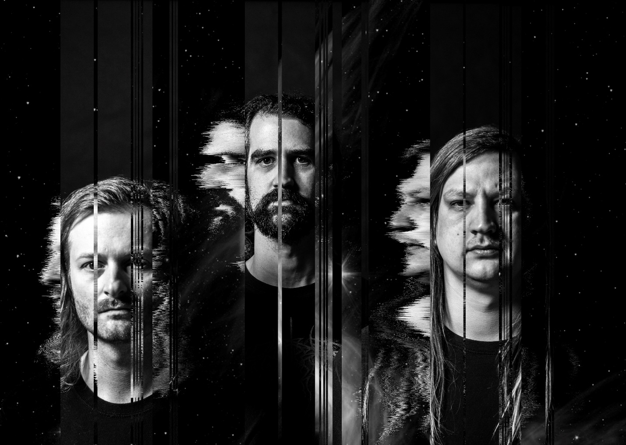

**DRUIDS Press Photo by Suzanne Corum-Rich**