**For Immediate Release**

**February 28, 2019**

**Eclectic Progressive Metal Quartet VALENCE to Release New Album, “Cognitive Dissidents”, on April 12, 2019**

**Watch New Music Video for “Damnit, Lana!” Now via** [**Metal Injection**](http://www.metalinjection.net/video/valence-flex-their-twisted-proggy-jams-on-damnit-lana)

**Pre-Orders Available** [**Bandcamp**](https://valence.bandcamp.com/album/cognitive-dissidents) **|** [**iTunes**](https://itunes.apple.com/us/album/cognitive-dissidents/1454614112) **|** [**Spotify Pre-Save**](https://distrokid.com/hyperfollow/valence/cognitive-dissidents-2)

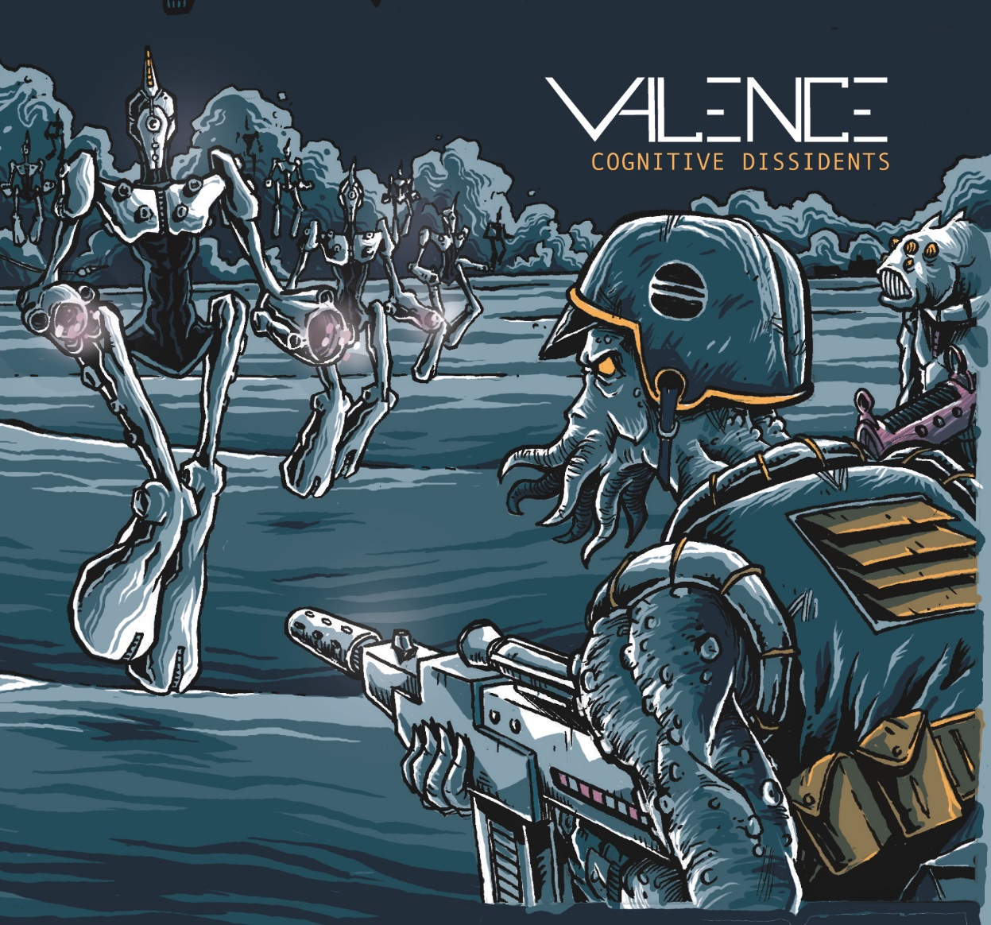

*“…****VALENCE*** *is a style unto themselves, and listening to them is more about a direct connection to the moment than a study of any genre.”*

- **William Berger, Author, *Wagner Without Fear* et al.;**

**Producer and Commentator, the Metropolitan Opera**

Fans of completely unpredictable progressive metal, lend your ears! Hailing from New York, instrumental quartet **VALENCE** is here to feed your need for sweet technicality, masterful melody and outstanding musical genius – wrapped tight and tied with a Sci-Fi bow. Expertly fusing genres like metal, rock, jam, classical, jazz, and more, **VALENCE**’svaried yet cohesive influences offer every listener a passport to a new state of mind that is cerebral and emotive, while not sacrificing accessibility.

On April 12, 2019, **VALENCE** will make yet another epic statement, by releasing the follow up to their Independent Music Award-winning 2014 EP, *Laser Baron*. The ambitious new full-length album, entitled ***Cognitive Dissidents***, was recorded and produced at Westfall Studios in Long Island, NY and clocks in over 50 minutes of tantalizing auditory storytelling.

Check out **VALENCE**’s brand new music video for the whirlwind album intro opus “Damnit, Lana!” now via **Metal Injection**: <http://www.metalinjection.net/video/valence-flex-their-twisted-proggy-jams-on-damnit-lana>

Guitarist Geoffrey Schaefer says, *“Damnit, Lana!” was the clear choice as the lead single for the album because it hits you like a ton of bricks right from the start. And while it’s one of our shreddiest songs, it’s also stylistically pretty eclectic.”*

**VALENCE** wastes no time in launching ***Cognitive Dissidents*** intro the stratosphere with lead single “Damnit, Lana!”, setting the course for what is about to be one hell of a ride. Rock technicality blends into a seductive Latin fusion-inspired section driven by multi-talented percussionist Chris Romano, only to finish as an unrelenting metal opus. “II. Calmer Than You Are” shows the softer side of **VALENCE**, illustrating a synth-laden soundscape led by bassist Wilhelmus Sapanaro. The band continue to flex their tech-muscles on tracks like “III. Preferred Nomenclature”, in which guitarists Michael Buonanno and Geoffrey Schaefer burn through over five minutes of deft ebb and flow – fluxing between absolute mano-a-mano, battle-like shreddery, deep grooves and classically-influenced passages. “Walrus”, amid its journey, provides an unexpected mid-track jam trip before the album closes with “Red Sky at Morning” – a 14+ minute sonic escapade that can only be described as positively monumental.

Rather than utilizing samples, bassist Wilhelmus Sapanaro performed upright bass and cello and guitarist Michael Buonanno performed violin and viola on ***Cognitive Dissidents*** to maintain an organic sound.

Guitarist Michael Buonanno says, *“We approach our music much like a composer would a piece of classical music. We write long-form pieces that treat the different instruments (and the various effects we use) like different parts of an orchestra and have an almost narrative quality to them. None of our songs are about showcasing the talent or playing of a single musician, but really feel like songs written for an ensemble.”*

Geoffrey Schaefer adds, *“****Cognitive Dissidents*** *isn’t a concept album in the sense that it tells a specific story (the way our EP, Laser Baron, did), but there are musical ideas – melodies and chord progressions – that appear throughout the album and make it all feel cohesive and connected.* *The way we see it, the album is made up of four distinct “pieces” of music: “Damnit, Lana!”, “The Dude Suite” (which is broken up into four separate sections/tracks), “Walrus” and “Red Sky at Morning.” We feel this allows for each song to stand on its own, while still containing these recurring themes that connect them.”*

**VALENCE** has performed across the eastern United States and Canada with artists like **Scale The Summit**, **Sarah Longfield**, **Consider The Source**, **Felix Martin** and more, and will soon expand their national footprint later in 2019. In the meantime, **VALENCE** has several U.S. performances booked this winter and spring. See below for all confirmed tour dates:

**VALENCE Tour Dates:**

4/13 - Poughkeepsie, NY @ Darkside Records - **Record Store Day**

4/26 - Holbrook, NY @ Rams American Pub

4/27 – New Brunswick, NJ @ The Chocolate Shop

4/28 - Philadelphia, PA @ Milkboy

4/29 - Orange, VA @ 3 B’s Bar & Grille

5/1 - Raleigh, NC @ Slims

5/2 - Atlanta, GA @ Smith’s Olde Bar

5/3 - Asheville, NC @ Odditorium

5/24 - Brooklyn, NY @ Saint Vitus w/ **Black Crown Initiate** // Album Release Show

Visit this [Facebook invite](https://www.facebook.com/events/439815169894139/) for a listing of these shows.

***Cognitive Dissidents* track listing:**

1. Damnit, Lana!

2. Prelude: Parlance of Our Time

3. I. If You’re Not into the Whole Brevity Thing

4. II. Calmer Than You Are

5. III. Preferred Nomenclature

6. Walrus

7. Red Sky at Morning

**VALENCE online:**

[www.valence.band](http://www.valence.band)

[www.facebook.com/valencemusic](http://www.facebook.com/valencemusic)

[www.valence.bandcamp.com](http://www.valence.bandcamp.com)

[www.youtube.com/valenceband](http://www.youtube.com/valenceband)

**VALENCE is:**

Michael Buonanno – Guitar, Violin, Viola

Geoffrey Schaefer - Guitar

Wilhelmus Sapanaro – Bass, Upright Bass, Cello

Chris Romano – Drums

*“Ever watch a band enjoy themselves so much while playing live, that their mood becomes Infectious? It’s literally impossible not to smile while these dudes are having the best time on stage. It also helps that they can all super shred on their instruments too.”*

– **Metal Injection**

*“If you love some of the acrobatic, complex, and heavy material of current acts like* ***Scale the Summit****,* ***Between the Buried and Me*** *and* ***Animals as Leaders****, this is a band you need to check out.”*

-- **Sea of Tranquility**

*“When we hear prog, we actually expect the music to suck hard like a mouthful of coarse-grade sandpaper, because we know it’s a clever ruse. It’s a way for many failed musicians to pretend they have relevance.* ***VALENCE****, however, have given us more to expect out of this “prog” thing…”*

– **Deaf Sparrow**

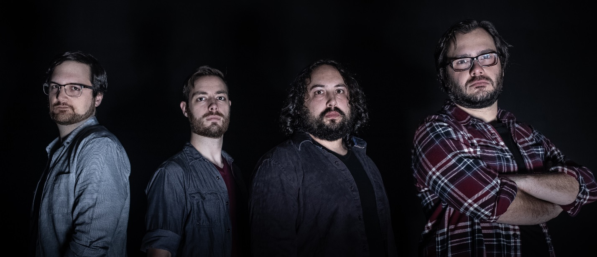

**VALENCE by Marissa Rodriguez of Scryer Photo**