**For Immediate Release**

**April 9, 2019**

**Eyellusion Presents the DIO RETURNS U.S. Tour 2019,**

**Featuring the DIO Band and Special Guest Vocalists**

**Featuring the Ronnie James Dio Hologram Performing Live + Tim “Ripper” Owens and Oni Logan as Guest Vocalists**

***Celebrate the Music and Legacy of Ronnie James Dio!***

**Tickets On Sale this Friday, April 12 at 10:00 AM Local Time via All Venues**

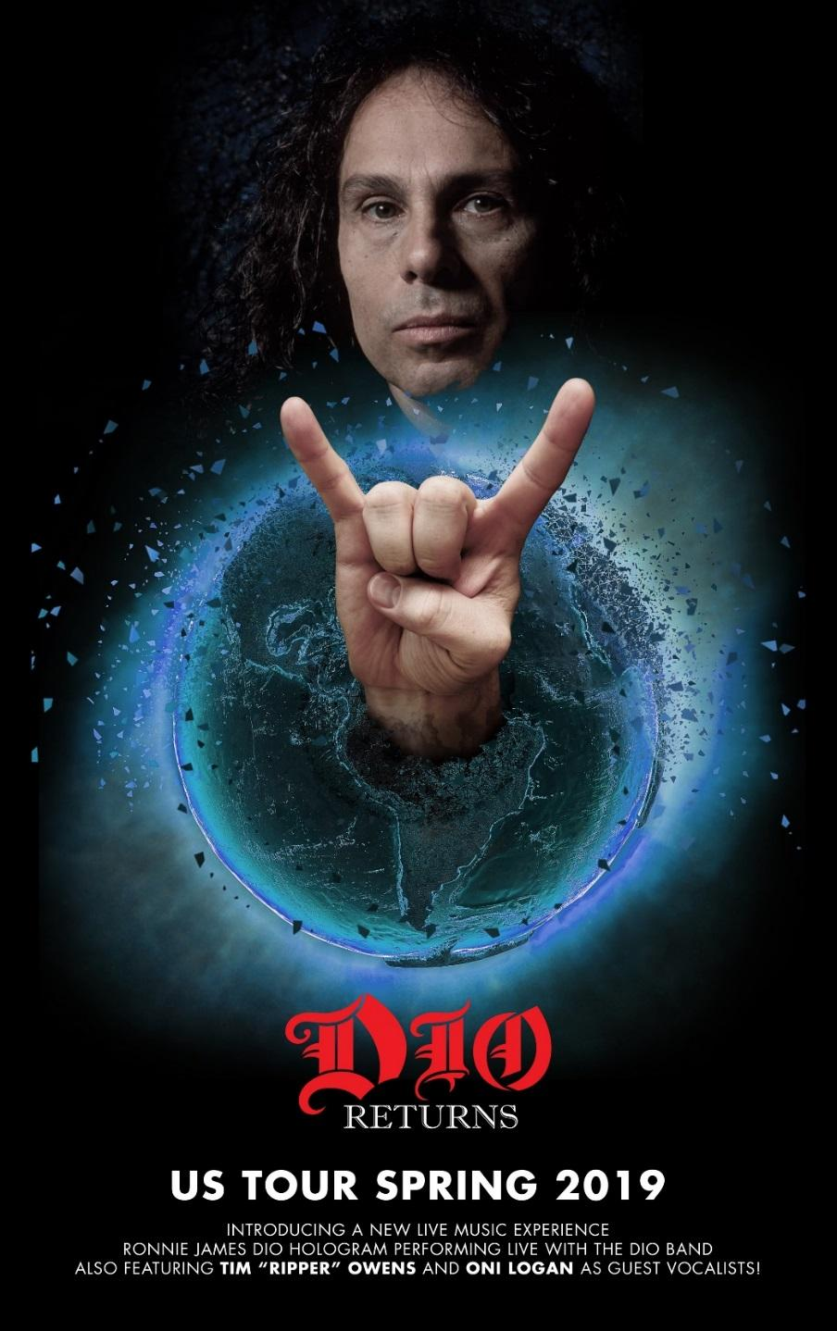

The most buzzed-about tour in the heavy metal world – the **DIO RETURNS** Tour featuring the **Ronnie James Dio** hologram – is finally coming to the United States this spring and summer! The **DIO RETURNS** U.S. Tour will feature a line-up of **DIO** bandmembers of 17 years performing aside the stunning **Ronnie James Dio** hologram.

The official band line-up will feature Craig Goldy on guitar, Simon Wright on drums, Scott Warren on keyboards, and newer **DIO** family member Bjorn Englen on bass. The show will also feature renowned metal vocalists Tim ‘Ripper’ Owens (**Judas Priest/Yngwie Malmsteen**) and Oni Logan (**Lynch Mob**).

This 90-minute celebration of **Ronnie James Dio** will include all of the greatfan favorites – such as “Holy Diver”, “King of Rock N’ Roll” and “We Rock” – taking fans on a **DIO** journey from **Rainbow** to **Black Sabbath,** to his own **DIO** material – with the legend himself!

The **DIO RETURNS** Tour will begin May 31, 2019 in Ft. Myers, FL and visit a month’s-worth of cities, with more dates set to be announced.

Tickets for all confirmed tour dates go on sale this Friday, April 12 at 10:00 AM local time via all major ticketing outlets. For more information, please visit [www.ronniejamesdio.com/tour.html](http://www.ronniejamesdio.com/tour.html).

Simon Wright says, *“Looking forward to hitting the road with this incredible piece of technology and celebrating Ronnie and his timeless music again with his friends and fans.”*

**DIO RETURNS 2019 U.S. Tour Dates:**

May 31 - Ft. Myers, FL @ Barbara B. Mann Performing Arts Hall

June 1 - Orlando, FL @ The Plaza Live

June 2 – St. Petersburg, FL @ Palladium Theatre

June 3 - Atlanta, GA @ Center Stage Theatre

June 6 - Worcester, MA @ The Palladium

June 7 - Glenside, PA @ Keswick Theatre

June 8 - Asbury Park, NJ @ Paramount Theatre

June 9 - Huntington, NY @ The Paramount

June 11 - Detroit, MI @ The Fillmore

June 12 - Grand Rapids, MI @ 20 Monroe Live

June 14 - St. Charles, IL @ The Arcada Theatre

June 15 - St. Paul, MN @ Myth

June 16 - Milwaukee, WI @ Pabst Theater

June 19 - Kansas City, MO @ Uptown Theater

June 20 - Oklahoma City, OK @ The Criterion

June 21 - Dallas, TX @ Bomb Factory

June 28 - Los Angeles, CA @ The Wiltern

June 29 - Las Vegas, NV @ Brooklyn Bowl

*+ More TBA!*

In August 2016, Eyellusion surprised fans when it debuted the **Ronnie James Dio** hologram at the Wacken Open Air heavy metal festival in Germany. The hologram was also tapped to open the 2017 Pollstar Awards, wowing bookers and promoters in attendance and creating excitement for the forthcoming tour. Most recently in December 2017, thousands of fans in Germany, Poland, Spain, Romania, the UK, Netherlands, and Belgium experienced **DIO** like never before via the **DIO RETURNS** tour.

For the past year, the presenting team at Eyellusion have been perfecting the production and unbelievable visual effects behind the amazing new **Ronnie James Dio** hologram. Watch a new trailer of the hologram in action here: <https://youtu.be/S94odyYYdKs>

Jeff Pezzuti, CEO of Eyellusion says, *“****Ronnie James Dio*** *was not only known for his amazing vocals, but also his incredible stage shows and performances. This show is a must see for all fans of Ronnie, new and old. The new stage production we have created plus the brand new* ***Ronnie James Dio*** *hologram have to be seen to be believed. This is a first of its kind metal show! We are celebrating Ronnie, with his live vocals, with his band he toured with for the last 17 years, and with a show that his fans will love! It’s an over the top metal experience that will have the fans raising their horns throughout the show! We are excited for everyone to see what we have in store for the U.S. beginning on May 31 and the world to follow!”*

For more information on the **DIO RETURNS** U.S. Tour 2019, please vist [www.ronniejamesdio.com](http://www.ronniejamesdio.com), or the social media sites below.

Facebook: [www.facebook.com/officialronniejamesdio](http://www.facebook.com/officialronniejamesdio)

Twitter: [www.twitter.com/officialrjdio](http://www.twitter.com/officialrjdio)

Instagram: [www.instagram.com/_ronniejamesdio](http://www.instagram.com/_ronniejamesdio)

For more information, visit [www.eyellusionlive.com](http://www.eyellusionlive.com) and follow the company @eyellusionlive on Twitter and Instagram.

**About Eyellusion:**

Eyellusion is live music’s premier hologram entertainment company. It provides end-to-end hologram production services, from live streaming to full digital recreation. As music industry business models evolve, Eyellusion is working with a fast-growing roster of artists to open up new revenue streams, expand touring capabilities and meet fan demand. The Eyellusion team brings decades of global music industry and live touring experience, combining deep expertise with cutting-edge production and hologram display capabilities. Eyellusion is based in Los Angeles with offices in New York.

--

**For press inquiries and additional information, please contact Adrenaline PR:**

**Maria Ferrero, 732-462-4262,** [**maria@adrenalinepr.com**](mailto:maria@adrenalinepr.com)