**For Immediate Release**

**September 4, 2019**

**Stoner-Prog Trio APE SHIFTER Announces First-Ever North American Tour Featuring Bass Legend Stu Hamm**

**Tour Kicks Off October 5 in Brooklyn**

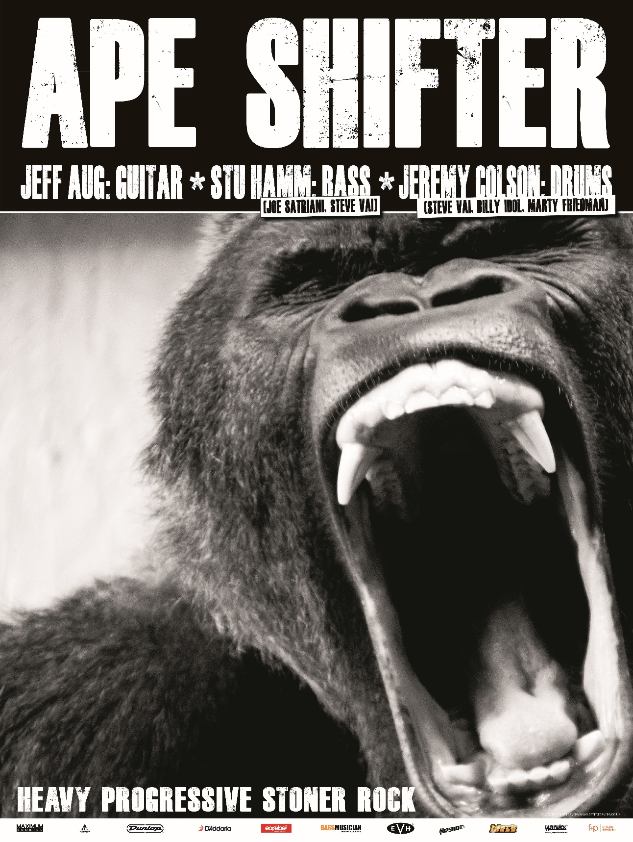

German-based progressive-stoner rock trio **APE SHIFTER** will debut on North American shores this fall, featuring the extraordinary lineup of **APE SHIFTER** leader/guitarist Jeff Aug, legendary bassist Stu Hamm and drummer Jeremy Colson.

Stu Hamm, whose resume includes performing with **Joe Satriani**, **Steve Vai** and **Caifanes**, says, *“I have known Jeff and his music for years, and Jeremy and I are going to KICK THE SHIT out of this music on the* ***APE SHIFTER*** *tour!”*

**APE SHIFTER**’s second album, *Ape Shifter II*, was released earlier this year to critical acclaim. Fusing a classic heavy rock sound that arcs in the stoner rock direction with technical musical prowess, **APE SHIFTER** is dissimilar from any other progressive instrumental band.

*“It is instrumental music without sounding like nerd rock,”* says Jeremy Colson, who also currently drums for **Steve Vai** and has worked with **Billy Idol** and **Marty Friedman**. *“It is punk rock mentality with heavy grooves!!!”*

Since releasing their self-titled debut in March 2017, **APE SHIFTER** has completed several European club tours and has shared bills with **Loudness** and **The Skull**, among others. Festival performances have included the main stage at Zytanien, Burg Herzberg Festival, OBOA, Free n Easy, Festival Kult!, and others.

Say Jeff Aug, *“…Atomic Bitchwax comes close, but there is no one on the planet doing what* ***APE SHIFTER*** *does.”*

Born in Washington, D.C. and raised in nearby Laurel, MD, Jeff Aug relocated to the foothills of the Alps in Southern Germany over 20 years ago. Since then, he has toured with notable musicians such as **Allan Holdsworth**, **Soft Machine**, **Greg Howe**, **Alex Skolnick**, **Carl Verheyen**, **Johnny A.**, **Albert Lee**, and has performed shows with an eclectic mix of artists including **Jawbox**, **Shudder To Think**, **Joan Jett**, **Thee Hypnotics**, **Scorpions**, **Alice Cooper** and **Body Count** with a previous band. He's worked with John Stabb from **Government Issue**, has been touring and recording with **Anne Clark** for the last 15 years and has been touring as a solo guitarist for more than 25 years.  Aug can also be heard on the **Atari Teenage Riot** album *Is This Hyperreal?*.  Not surprisingly, Aug set the world record for the "most concerts performed in different countries in 24 hours,” not once but *twice* in 2009 and 2012). He´s been featured on NPR´s show *Morning Edition* and has had a #1 selling album on iTunes Acoustic Music Charts in the U.S.

For a sample of **APE SHIFTER**, please click on the links below:

“Haskett” - <https://youtu.be/B1HuM1bw_2U>

“7 Years Fat, 7 Years Lean” - <https://youtu.be/ohccQmEgXhE>

“Uhluhtc” - <https://youtu.be/LqE5iatY7uU>

Stream **APE SHIFTER**’s album here:

*Ape Shifter I*:  <https://www.youtube.com/watch?v=iaiPYway2mk>

*Ape Shifter II*:  <https://www.youtube.com/watch?v=9XVQcvKN8Rg>

*“…with a touch of 70s rock here, a dash of Joe Satriani and Eddie Van Halen stylings there, while a couple of tracks, ‘Die Rausschmeiber’ and ‘Fu Manchu,’ wouldn’t be a million miles out of place if Vince Neil howled, wailed and hollered over the top of them!* - Sea of Tranquility

**APE SHIFTER Tour Dates:**

10/5 - Brooklyn, NY @ Sunnyvale

10/6 - Montreal, QC @ Bar Le Ritz

10/7 - Quebec City, QC @ L’Anti

10/8 - Ottawa, ON @ Mavericks

10/9 - Toronto, ON @ Hard Luck

10/10 - Detroit, MI @ Sanctuary

10/11 - Youngstown, OH @ Westside Bowl

10/12 - Chicago, IL @ Reggies

10/13 - Minneapolis, MN @ 7th St. Entry

10/14 - Lincoln, NE @ Bourbon Theatre

10/16 - Salt Lake City, UT @ Metro Music Hall

10/18 - Vancouver, BC @ Astoria

10/19 - Seattle, WA @ El Corazon

10/22 - San Francisco, CA @ Bottom of the Hill

10/23 - Los Angeles, CA @ Resident

10/26 - Tempe, AZ @ Yucca Tap Room

10/27 - Albuquerque, NM @ Launchpad

10/28 - Ft. Worth, TX @ Lola’s

10/29 - Austin, TX @ Come and Take It Live

11/02 - Frederick, MD @ Cafe 611 (w/ Spiral Grave and Almost Honest - presented by Maryland Doom Fest)

**APE SHIFTER Online:**

[www.ape-shifter.com](http://www.ape-shifter.com)

[www.facebook.com/apeshifter](http://www.facebook.com/apeshifter)