**For Immediate Release**

**October 2, 2019**

**Chicago-Based Hard Rockers BLACKLIST REGULARS Announce Fall Tours with Powerman 5000 + (HED) p.e. and Adema**

**Powerman 5000 Kicks Off October 16 | (HED) p.e. and Adema Kicks Off on November 19**

**BLACKLIST REGULARS’ Debut Album, “Through the Blast,” Available Now via Pavement Entertainment**

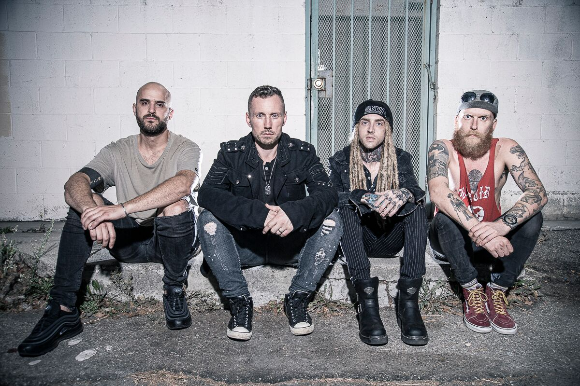

Chicago-based hard rockers **BLACKLIST REGULARS** have been tapped for two tours this autumn season, beginning with **Powerman 5000** on October 16 and followed by **(HED) p.e.** and **Adema** on November 19.

*“We can’t wait to rip it up on the upcoming* ***Powerman 5000*** *and* ***(Hed)p.e.*** *fall tours,”* says vocalist Luke Keating. *“We are stoked to be part of such stellar lineups.”*

**BLACKLIST REGULARS**’ debut album, *Through the Blast*, which was released this past spring via Pavement Entertainment, puts a modern spin on the hard rock genre. It is at once melodic, dynamic and hard hitting, with screaming guitar lines and grunge rock inspired bass backed by the powerful and precise drums.

Despite being based in the Windy City, **BLACKLIST REGULARS** hail from around the globe: Native Irishman Luke Keating fronts the band, along with Las Vegas guitarist Dylan Dice, Danish expat Philip Nielsons on bass and Kenosha, WI’s Nick Kraeuter on drums.

*“****BLACKLIST REGULARS*** *are an in your face rock band with an international twist!”* Keating proclaims.

**BLACKLIST REGULARS** have been featured on commercial rock stations such as Wisconsin’s WIIL Rock 95, where they were their song “Superhuman” was “Hit of the Day” and Rock 94.7 as the “[Spotlight Artist](https://rock947.com/blogs/ryans-regards/738/interview-with-luke-keating-of-the-blacklist-regulars-1/?fbclid=IwAR2BJk9VYXJIfad8Zq6n9J5aVy97fhVpzN8AihSf8V8br--6UOUPnKmYZhY),” and have also received support from Illinois’ Q100.7’s “[Noon Takeover”](https://www.qrockonline.com/shows/elwood/) and Ontario-based Rock 95FM. They have also received 30,000-plus plays on [Spotify](https://open.spotify.com/artist/2chI98UeoCpYMOWZ4SF3ko), 60,000-plus plays on [Pandora](https://www.pandora.com/artist/blacklist-regulars/ARX66hl9pn73PKm) and more than 25,000 views on [YouTube](https://www.youtube.com/channel/UCfaVT6SJnnZKKGIeQt0n9aw).

**BLACKLIST REGULARS tour dates with Powerman 5000:**

10/16 – Herman’s Hideaway, Denver, CO

10/18 - Q + Z Expo, Ringle, WI

10/19 - Venue 1175, Janesville, WI

10/20 - Electric Room, Angola, IN

10/22- The Room, Highland, IN

10/23 - Alrosa Villa, Columbus, OH

10/24 - Manchester Music Hall, Lexington, KY

10/25 - Blue Note Harrison, Harrison, OH

10/26 - Hard Times Cafe, Alexandria, VA

10/27 - The Vault Music Hall, New Bedford, MA

10/28 - Granite State Music Hall, Laconia, NH

10/30 - Dingbatz, Clifton, NJ

11/01 - The Empire Concert Club, Akron, OH

11/02 - Fish Head Cantina, Halthorpe, MD

110/3 - The Glasshouse, Lynchburg, VA

110/5 - The Firmament, Greenville, SC

11/07 - Brauer House, Lombard, IL

11/08 - St. Croix Casino, Turtle Lake, WI

110/9 - Machine Shop, Flint, MI

11/10 - The Citadel Music Hall, Indianapolis, IN

11/13 - The Royal Grove, Noblesville, IN

11/14 - Sunshine Studios Live, Colorado Springs, CO

11/15 - Liquid Joes, Milcreek, UT

11/16 - Counts V'ampd, Las Vegas, NV

**BLACKLIST REGULARS tour dates with (HED) p.e. and Adema:**

11/19 - Bossanova Ballroom, Portland, OR

11/20 - El Corazon, Seattle, WA

11/23 - TIKI Bar, Costa Mesa, CA

11/24 - Encore, Phoenix, AZ

11/26 - 1927 Venue, Enid, OK

11/27 - The Rock Box, Fredericksburg, TX

11/29 - Scout Bar, Houston, TX

11/30 - Trees, Dallas, TX

12/01 - The Railhead Saloon, Lawton, OK

12/03 - Lazy Harry's Bar & Grill, Bullhead City, AZ

**BLACKLIST REGULARS is:**

Luke Keating - Vocals  
Nick Kraeuter - Drums  
Dylan Dice - Guitar  
Philip Nielsen - Bass

**BLACKLIST REGULARS online:**

[www.blacklistregulars.com](http://www.blacklistregulars.com/)

[www.facebook.com/BlacklistRegulars](http://www.facebook.com/BlacklistRegulars)

[www.instagram.com/blacklistregulars](http://www.instagram.com/blacklistregulars/)