**For Immediate Release**

**September 30, 2019**

**Celtic Vocalist LEAH to Release “Ancient Winter” Winter-Themed Album on November 15**

**Watch the Video for “Redemption”** [**Here**](https://youtu.be/POEiK6kKH2E)

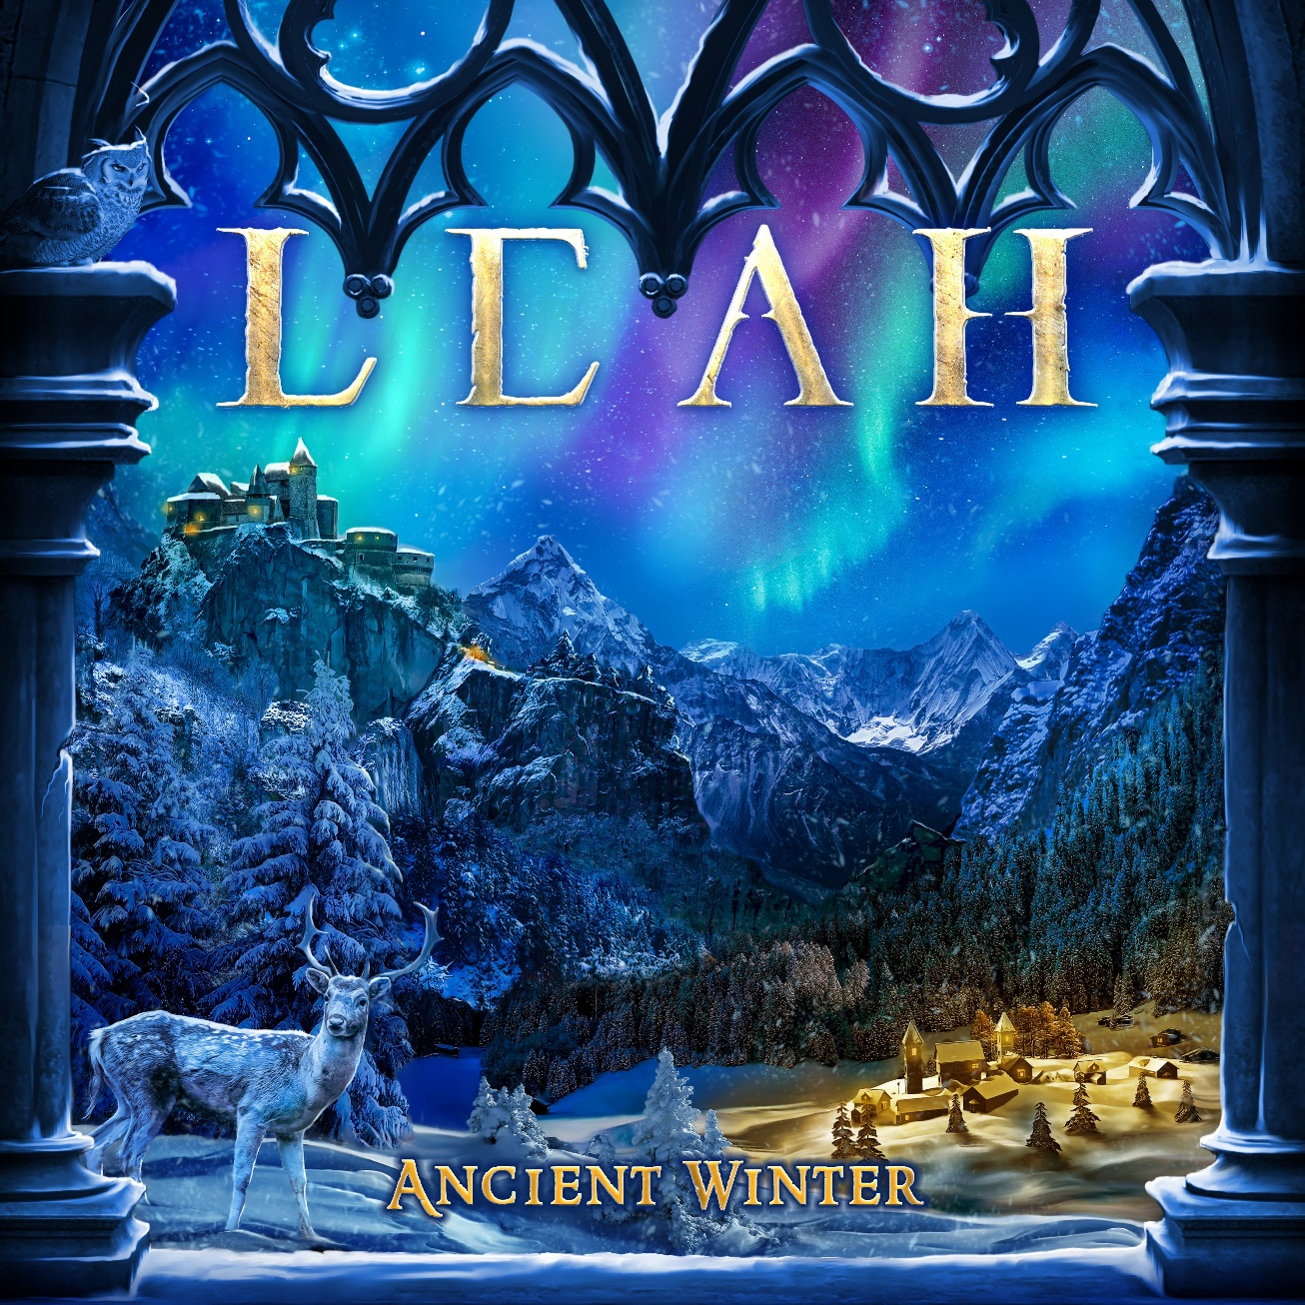

After a crowdfunding campaign that far exceeded the goal, symphonic/Celtic vocal goddess **LEAH** has revealed that her upcoming winter-themed album, ***Ancient Winter***, will officially see release on November 15.

Says **LEAH**, *“Now that the crowdfunding campaign is complete, I’m really excited to focus on the release of this album in November. My closest colleagues have told me this album might be some of my best work yet. Regardless, I hope this new music will make the coming winter season much more magical.”*

***Ancient Winter*** features eight tracks – five of which are originals and three traditional century medieval songs that **LEAH** puts her own unique touch on. The album offers a slight departure from **LEAH**’s traditional symphonic metal into a more atmospheric, ethereal sound. It is a more earthy sounding album filled with new instrumentation such as fiddles and uilleann pipes, which give it a beautiful harmony of middle eastern feeling and Celtic folk and fantasy. ***Ancient Winter*** proves **LEAH**’s ability to venture into musical realms beyond metal.

***Ancient Winter*** represents a new approach to holiday music as it celebrates winter themes in a way that is sure to give it a wider appeal. This is not simply a “Christmas album” but rather an emotional journey into transcendent ideals that will inspire any listener from anywhere.

***Ancient Winter* Tracklisting:**

The Whole World Summons

Light of the World

Upon Your Destiny

Redemption

The Messenger

Gaudete

Puer Natus

Noël Nouvelet

For ***Ancient Winter***, **LEAH** tapped a top-notch talent cast of musicians, including Troy Donockley (**Nightwish**), Anna Murphy (**Cellar Darling**), Shir-Ran Yinon (**Eluveitie**), Oliver Philipps (**Everon**, **Phantasma**) and renowned string musician Rupert Gillett. This diverse lineup adds an international flavor to the album alongside **LEAH**’s beautiful vocals.

A variety of bundle packages will be available soon at [www.theleahshop.com](http://www.theleahshop.com). Watch the lyric video for “Redemption,” the first single from ***Ancient Winter***, here: <https://youtu.be/POEiK6kKH2E>

**LEAH** has amassed a generous and dedicated fanbase that has allowed her to crowdfund three of her five recordings without the assistance of a record label. **LEAH**’s first four albums, *Of Earth and Angels* (2012), *Otherworld* (2013), *Kings & Queens* (2015), and *The Quest* (2018) are a rapturous blend of a symphonic metal style carefully spiced with Celtic, folk and fantasy. Her emotive vocals are often compared to **Loreena McKennitt**, **Tori Amos** and **Sarah McLachlan**.

**About LEAH:**

**LEAH -** described affectionately by her fans as “the metal Enya” - hails from the coast of British Columbia, Canada, and is inspired by Celtic and world music influences such as Clannad and Enya to European symphonic and progressive metal influences. Her debut self-released album *Of Earth & Angels* received international critical acclaim, including landing the “The Best Symphonic Metal Album” Metalstorm Award for 2012. Her 2013 release, *Otherworld*, is a five-song Celtic-metal masterpiece, mixed by Christian "Moschus" Moos at SPACELAB in Germany (**Delain, Everon, Imperia**) and features the vocals of guitar legend Eric Peterson (**Testament/Dragonlord**) on the ethereal metal track “Dreamland.” 2014 was very successful year for**LEAH** as she raised over $27,000 through Indiegogo via her fans to record and produce her heaviest album, *Kings & Queens*, which was eventually released in early 2015 through Inner Wound Recordings. The album received dozens of four and five-star reviews, and helped her gain thousands of new fans around the world. **LEAH** raised over $87,000 in 30 days via Indiegogo and her shop to launch last year’s ***The Quest***, again released via her own independent record label, Ex Cathedra Records, along with Inner Wound Recordings. ***The Quest*** received 5-star reviews and critical acclaim.

**LEAH Online:**

Website: <http://leahmusic.net/>

Facebook: <http://www.facebook.com/leahthemusic>

YouTube: <http://www.youtube.com/user/leahthemusic>

Instagram: <http://instagram.com/leahthemusic>

Twitter: <http://twitter.com/leahthemusic>

