**For Immediate Release**

**January 8, 2020**

**Teenage Beautycore Metal Trio GFM (GOLD FRANKINCENSE & MYRRH) to Release New Joey Sturgis-Produced Single**

**“I Don’t Need Your Fantasy” Available January 10**

**GFM on Tour Now and Appearing at NAMM January 15-17**

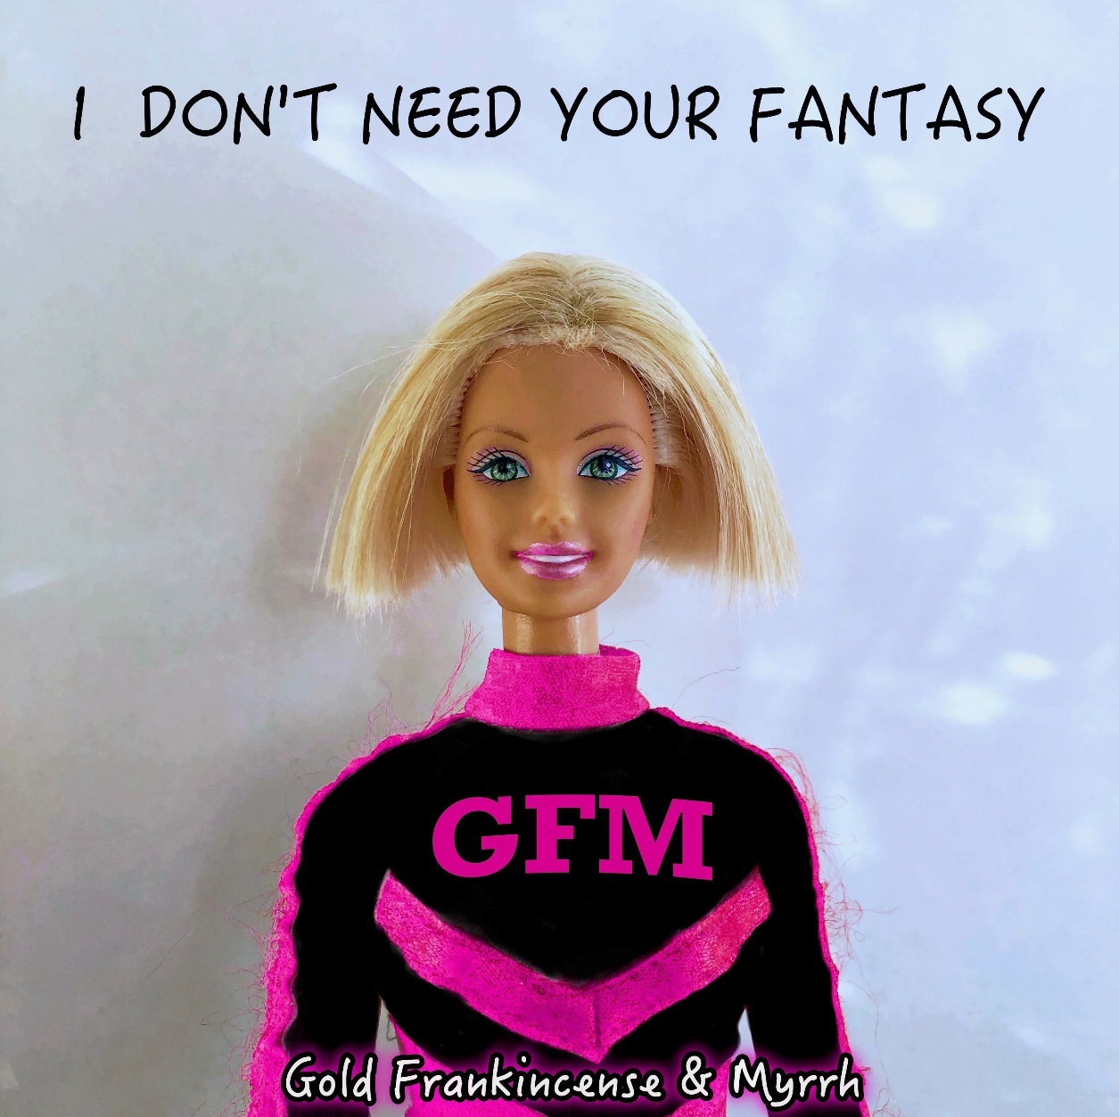

Balancing the melodicism of bands like **Paramore** with a **Slipknot**-like ferocity, the three teenage sisters of **GFM** (**GOLD FRANKINCENSE & MYRRH**) have created their own niche – a sound they have dubbed “beautycore” – exemplified on their new single, “I Don’t Need Your Fantasy,” produced by Joey Sturgis (**Of Mice & Men**, **The Devil Wears Prada**, **Attack Attack!**, **Asking Alexandria**).

*“’I Don’t Need Your Fantasy’ is about breaking stereotypes and letting go of the false perceptions that you think you have to carry,”* says bassist/vocalist Maggie English. *“You don’t have to live a cookie cutter life. You don’t have to change yourself just so people might like you better. We’re being unapologetically ourselves, and we’re taking the world by storm.”*

Clearly not your average teenage girl band, CJ English (guitar/vocals), Maggie English (bass, keyboards, vocals) and LuLu English (drums, vocals) are breaking boundaries in the music industry and bringing life back to rock and metal with **GFM**’s encouraging and positive message.

*“You can tell when someone is passionate about music,” says Joey Sturgis. “You can hear it in the way they sing each line or play each note - and these girls have it.* ***GFM*** *has a fire that won’t be put out and a passion that can’t be matched. This band is a prime example of where music is going as a business. The industry is changing and these girls are at the forefront of the evolution that’s happening. It’s exciting to watch and be a part of!”*

The sisters all began taking music lessons at just five years old, which sparked a love of music that would continue to grow. As they grew up, the girls collectively decided that they wanted to pursue this love for music professionally, and began putting blood, sweat, and lots of tears into creating **GFM**.

**GFM**’s first album, *Identity Crisis*, was released in 2016, followed by *Oh, The Horror!* in April 2019. After touring the US multiple times, the group headed overseas to Germany in 2018, where their energetic performances established **GFM** as a festival favorite. A new EP is scheduled for release this spring.

**GFM** is currently on tour in the US and will be at several NAMM events, including the Women at NAMM Event on Wednesday, January 15 from 6:30 to 7:30 p.m., SJC Drums’ event at Chain Reaction from 4:30 to 10 p.m. on January 17 and the Gator booth at 1 p.m. on January 18.

**GFM (GOLD FRANKINCENSE & MYRRH) tour dates:**

1/7 - Hereford, TX - The Nazarene Church

1/9 - Prescott, AZ - Restoration Church

1/10 - San Gabriel, CA - San Gabriel Christian School

1/11 - Corning, CA - New Life Assembly

1/12 - Victorville, CA - 1st Assembly of God

1/17 – Anaheim, CA - Women at NAMM Event @ Anaheim Convention Center

**What others have been saying about GFM:**

*“CJ, Maggie and Lulu are a glowing ball of positive energy that radiates from the stage and into their fans’ lives.  When you encounter* ***GFM****, be it through their music or in person, you are truly changed for the better.  From their hard-driving shows to their lighthearted and sometimes deep social media events, everyone they touch is truly #TeamGFM once they leave.  And it isn't a one-time offer either; you are family from the start.”* - Rock 98.9 (Jacksonville, FL)

*“Beautycore is real and it’s coming at ya full steam!!! You’ll rarely find a band as dedicated to their craft as* ***GFM****. Not just a bunch of pretty faces, this group consumes all things pop/punk/metal and have created their own ear-shattering style (in an excellent way). No two songs are ever the same and they’re always sprinkling in new flavors to keep things fresh. These ladies are busting through barriers while providing people of all ages and walks of life the ultimate life-changing message of love and hope. Get on the train now, because this group has a long, blazing future in front of them and you’ll regret missing a single note!!!”* - Jon Walden/Revocation Radio (Birmingham, AL)

*“Never in my 25 years of mixing have I seen such dedicated/focused music prodigies... I can truthfully say I'm honored to be able to be a small part of their sound.”* – Producer Billy Decker

*“****GFM*** *is one of those groups that absolutely radiates talent and drive, and their passion for writing and performing is something that is truly inspiring. It’s really only a matter of time until these guys are ruling the rock charts and I feel extremely blessed to have played a small part in their journey.”* – Producer Eric Varnell

*“****GFM*** *is such a breath of fresh air. Heavy music mixed with a positive message in a voice that resonates with young people. The musical connection all three sisters share is unparalleled.”* - Carmen Mark “Squiggy” DiGiacomo/*Loudwire*

**GFM is:**

CJ Sanders English – Guitar, Vocals

Magdalene “Maggie” Rose English – Bass, Vocals

Evie “LuLu” Louise English – Drums, Background Vocals

**GFM online:**

[www.instagram.com/thegfmband](http://www.instagram.com/thegfmband)

[www.facebook.com/thegfmband](http://www.facebook.com/thegfmband)

[www.twitter.com/thegfmband](http://www.twitter.com/thegfmband)

[www.youtube.com/thegfmband](http://www.youtube.com/thegfmband)

[www.patreon.com/thegfmband](http://www.patreon.com/thegfmband)

[www.bandsintown.com/gold,frankincense,andmyrrh](http://www.bandsintown.com/gold,frankincense,andmyrrh)

[www.thegfmband.com](http://www.thegfmband.com)



**Photo: JW Lee**